Satellite Switched Control

A relay with hysteresis has been used to allow for a reasonable simulation time. Otherwise the discontinuity of the switch will dramatically slow down the simulation as Simulink’s Dormand Prince algorithm tries in vain to select the correct integration step-size across the discontinuity.

The phase-plane below has been obtained for k=0.1, 0.5, and 1.

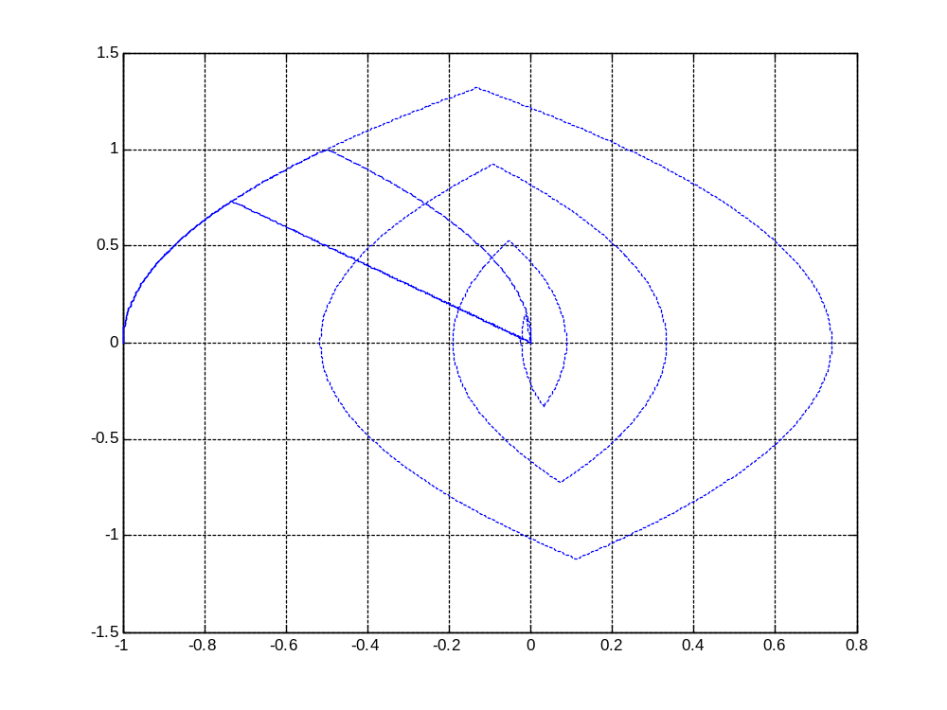
x₁
x₂
k=1
k=0.5
k=0.1

